Welcome Back!
Nearly 500 friends of the McArthur-Burney Falls Interpretive Association have subscrribed to our newsletter in the past. The ‘quarterly’ newsletter from MBFIA has been sporadic in recent years. We plan to revivie this tradtion and do our best to stick to a quarterly schedule. This newsletter is scheduled for early April and you can expect to see the next one in early July as America celebrates the Semiquincentennial of the signing of our Declaration of Independence. In the October newsletter we will look forward to Heritage day. And to finish the year, the January 2027 newsletter will start the Centennial celebration of the McArthur-Burney Falls Memorial State Park.

Upcoming Dates in 2026
- April 1 – Seasonal openings begin.
- Friday, April 3 – Visitor Center and Store open
- Sunday, April 5 – Easter
- Friday, May 1 – Season opens at the Falls
- Friday, May 15 – Reserved camping starts
- Friday, May 22-Sunday, May 24 – Memorial Day Weekend (Warning: Very busy roads.)
- Monday, May 25 – Memorial Day (adjusted)
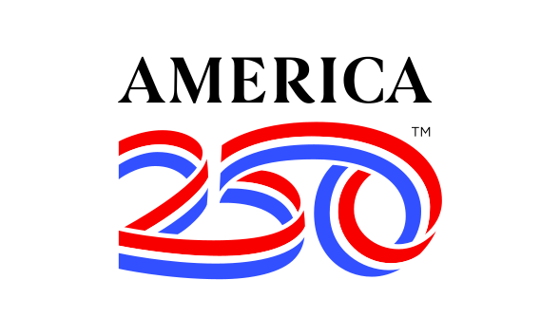
- Saturday, July 4 – 250th Anniversary Independence Day
- Monday, September 7 – Labor Day
- Saturday, September 12 – MBFIA Volunteer Appreciation Day & Lunch
- Sunday, October 11 – McArthur-Burney Falls Heritage Day Celebration
- Monday, October 12 – Columbus Day
- October 31 – Most seasonal facilities close
- Wednesday, November 11 – Veterans Day
- Thursday, November 26 – Thanksgiving
- Friday, December 25 – Christmas
- Friday, January 1, 2027 – New Years Day

About MBFIA
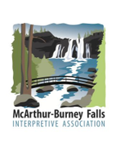
The McArthur Burney Falls Interpretive Association (MBFIA) is an all-volunteer non-profit education organization that provides assistance and funding for activities which enhance the quality of visits to McArthur Burney Falls Memorial State Park, Castle Crags State Park and Ahjumawi Lava Springs State Park. The association was founded in 1984 to promote greater appreciation of the cultural and natural history of the region.
Table of Contents
Welcome Back! 1
Upcoming Dates in 2026 1
About MBFIA 1
Donations 3
Board Members 3
Firewood at the Falls 3
Mission 3
President’s Message 4
2026 MBFIA Annual Plan 4
Board Meeting Highlights 6
A Wonder of the World 11
About the Three State Parks 11
McArthur-Burney Falls Memorial State Park 11
Castle Crags State Park 12
Ahjumawi Lava Springs State Park 13
Meet 13
The Newsletter Editor Tony Otto 13
Falls Visitor Center 13
Visitor Center Store 14
Featured Artist this Quarter: 14
Burney Falls General Store 15
Job Openings 15
MBFIA Bookkeeper 15
Camp Hosts 15
Visitor Services Senior Park Aide 15
Memorial Tables 16
Tribute 16
A Tribute to Generations of Families Who Vacation At Burney Falls 16
Tribute to Families that call McArthur Burney Falls Home 17
Friends of the Falls 17
Contact Infomation 18
On the Internet 18
MBFIA (McArthur-Burney Falls Interpretive Association) 18
Burney Falls General Store 19
MacArthur-Burney Memorial State Park 19
Castle Crags State Park 19
Ahjumawi Lava Springs State Park 20
April Featured Artist: Marla Nolan 20
Secret San Francisco Article 21

Donations
We are a group of volunteers who love and support our northern California State Parks. We operate gift shops, sell firewood and do other fund-raisers to help us help the parks!
All donations are used for educational and interpretive activities in the Park.
Did you enjoy the campfire and evening programs? These are supported by donations.
Did you or your child complete the Discovery Quest Challenge? The patch you received was paid for with donations.
Did you take a nature walk or a guided canoe trip on Lake Britten? These are supported by donations.
Is this Visitor Guide newspaper helpful and interesting? Donations paid for printing the paper.
Did you attend Heritage Day? Donations provide candle-making, beading, saw-bucking, rope-making, pine-doll building, apple cider press, and old time fiddle music. This celebration of life in the Intermountain Area in the 1870’s is provided thanks to donations.
Donations for the Park are accepted by the McArthur-Burney Falls Interpretive Association. An organization of volunteers from the communities around the Park, the Association is also known as the Friends of the Falls. We love the Park and we know that you do as well.
We encourage every visitor to make a donation in any amount to support activities in the Park. Checks may be made payable to MBFIA, Box 777, Burney CA 96013. Donation envelopes are available in the kiosk at the entrance or in the Visitor Center. We will list donors in next year’s Visitor Guide.

Board Members
- President Jim Sacson
- Vice President: Mark Downie
- Secretary: Ann Sacson
- Treasurer Emiritus: Jaci White
- Webmaster: Bob Boyce
- Tablemaster: Bill McSweeney
- Media Rep: Craig Harrington
- Newsletter Editor: Tony Otto
- Volunteer: Susan Lamke
- Alice Hoveman
- Jill Overbaugh
- Tom Stockton

Firewood at the Falls
The MFBIA has firewood in 0.8 cubic foot bags available just past the entrance kiosk and at the upper and lower campground areas when open. The cost is $10/one bag, $18/two bags, and $25/three bags.

Where does the Firewood Come From?
What would camping be without a campfire, and those marshmallows! Have you wondered where that nicely bagged wood comes from?
To start with, the wood itself comes from right here in the Park. We want to be sure that firewood does not bring in pests and diseases from out of the area. When trees die, are felled by storm or fire, or are cut down as hazards, the wood is cut and bagged in manageable amounts by inmates housed at the Intermountain Conservation Camp, managed by CalFire. These hard workers also do some of the hazard tree removal, trail repair, campground clean-up, weed eating and brushing, both here in Burney Falls and in Ahjumawi Lava Springs State Park. Their efforts supplement the hard work of the Park’s maintenance staff, MBFIA volunteers who replenish the wood sheds weekly, and save taxpayer funds.
On top of supporting a healthy forest, these efforts produce a significant portion of the proceeds each year for the McArthur Burney Falls Interpretive Association in support of campfire and evening programs, replacement of interpretive signs that have weathered dramatically in the last 10 years, bird and nature walks, the Discovery Quest and Junior Ranger programs, Heritage Day, other interpretive programs for young and old, including the production of the Visitor Guide.

MBFIA Mission Statement
The McArthur Burney Falls Interpretive Association is an all-volunteer non-profit education organization that provides assistance and funding for activities which enhance the quality of visits to McArthur Burney Falls Memorial State Park, Castle Crags State Park and Ahjumawi Lava Springs State Park. The association was founded in 1984 to promote greater appreciation of the cultural and natural history of the region.
MBFIA raises funds to support educational and interpretive activities, including interpretive personnel, and a printed Visitor Guide provided free to visitors. MBFIA manages the Visitor Center Gift Shop. Funds are raised through the sale of firewood, advertising in the Visitor Guide, the operation of the Visitor Center gift shop, and most importantly, donations from friends and visitors.

Friends of the Falls
Friends of Burney Falls provides education and interpretation and our programs highlight the Park's natural and cultural elements. Burney Falls offers hiking trails, flora and fauna, birds, squirrels and the like, camping, cabins and Lake Britton. Funds donated support Interpretive and educational activities, including guided hikes, Junior Ranger programs, campfire and craft activities, sing-alongs and group games. At Burney Falls, our Visitor Center includes a Gift Shop, as well as information about the geology, flora and fauna, cultural history and recreational opportunities in the park and the surrounding area. Our annual Heritage Day celebration in October offers weaving, cross-cut sawing, branding, candle-making, pine-doll making, apple cider pressing and Dutch Oven cooking. The Park has instituted a birding program, that includes guided bird identification walks, loaner binoculars plus a library of information. In addition, we have supported new native plants around the Visitor Center, with information about the plantings available for visitors.
We're also in the process of renewing our availability for sale and placement of memorial benches and picnic tables at the Park. Contact us for more details.

President’s Message
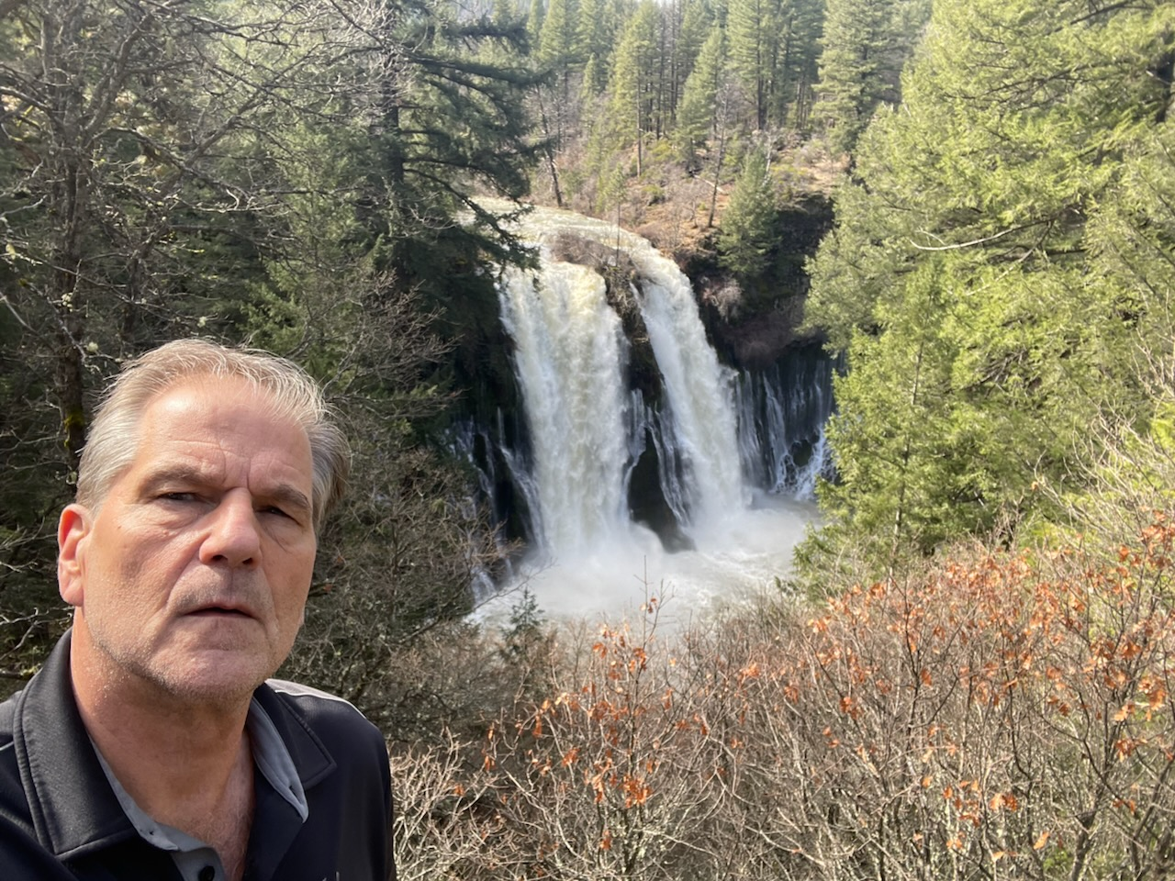
As President of the McArthur Burney Falls Interpretative Association, I am pleased to welcome visitors to the McArthur-Burney Falls Memorial State Park. In 1964, my family bought a home and property near the park. I had the tremendous opportunity of growing up here. My family enjoyed exploring the natural beauty and all of the outdoor activities the Intermountain area has to offer.
I served in the United States Navy after high school and had the privilege of traveling to many places around the world. My travels helped me appreciate how unique and untouched much of our mountain area has remained. It is my desire to help retain the natural beauty we get to enjoy every day.

2026 MBFIA Annual Plan

Board Business
- Raise $86,000 through donations, sales of Visitor Center Merchandise, Firewood and Visitor Guide Ads to support Interpretive Services at McArthur-Burney Falls Memorial, Castle Crags and Ahjumawi Lava Springs State Parks.
- Continue to recruit and expand Board membership with focus on public relations and financial expertise.
- Hire a bookkeeping service to manage revenue and expenditure throughout the season.
- Focus on Board development to provide leadership for Board projects; succession planning and training for transitioning of responsibilities.
- Provide opportunities for donations from the public on the MBFIA website and donation envelopes at the park with a goal of raising $3,500.
- Raise $2,500 coordinating the sale of one memorial table at MBF.
- Develop policies and procedures that will enable the sale of Memorial Benches for implementation in 2026.
- Continue partnership with the Mountain Jewels Ranch to recycle 4,000 pounds of plastic, aluminum and glass raising $2,100.
- Solicit a minimum of 9 businesses raising $3,000 for Visitor Guide Advertising at MBF.
- Continue to invest $20,000 in money market account @4% interest.

Visitor Centers Reopening
- Operate full-time Visitor Center Gift Shops at McArthur Burney Falls and Castle Crags State Parks with goal of raising $37,000.
- Provide access to MBF Visitor Center for 12,000 visitors, 5 days a week.
- Expand sale merchandise inventory and continue to support the new T-shirt designs at both MBF and Castle Crags.

Firewood Production and Sales
- Provide funding in the amount of $12,000 for processing 4,000 bundles of firewood for sale to campers at MBF and Castle Crags State Parks.
- Manage the sale of Firewood, stocking weekly supplies at campsites and entry wood sheds, with a goal of raising $37,000 in revenue.

Interpretive Services Projects
- Support the design and/or replacement of two Interpretive Panels in McArthur-Burney Falls and one panel in Castle Crags State Parks.
- Finish the replacement/repair the campfire benches; mill wood from downed trees providing material for replacement and repair of decaying benches in the campfire arena to complete the project.

Interpretive Program Support
- Print 35,000 20-page Visitor Guides for Mc Arthur Burney Falls Memorial State Park.
- Order 2,000 2026 Discovery Challenge Patches for MBF.
- Revise the Discovery Challenge Quiz Questions in the MBF.
- Provide funding in the amount of $1,000 to Shasta Wildlife Rescue and Rehabilitation to hold 10 camp fire presentations with live birds and animals for campers at MBF and Castle Crags State Park.
- Plan and schedule Heritage Day in October for 1200 visitors. Continue to re-envision the day with a broader look at the natural and human impact on the land, keeping in place what has been a successful involvement by local folks.
- Support at least 2 Art In The Park events at MBF State park in cooperation with local artists.

SPECIAL PROJECTS
In partnership with the State Park district, define and propose special projects that could be funded or managed by the Association at each park. Possible projects could include:
- Develop Volunteer Work Days that include minor amenities for the bathrooms, trash pick-up on the trails, beach rehabilitation, campfire bench repair and/or other such work projects.
- Support volunteers and staff at both parks during the season that will include water/drinks/snacks and end of season BBQ.
- Develop plans to build memorial benches from local downed trees for interested customers in both parks.

Board Meeting Highlights

January 2026
- Jim introduced Tony Otto and asked him to tell us a little about his background. Tony visited the area on grade school summer vacations and recently moved to the area two and a half years ago. He hopes to help by working with the Webmaster and working on brochures.
- Most budget items for 2026 will be the same as 2025. However, we do not have to contribute this year to the contingency fund as it was not used in 2025.
- Costs on lunches and bbq for events could be reduced by preparing less expensive items. Terri suggested hamburgers and hotdogs.
- Heritage Day vendor costs went up last year. We also replaced some needed equipment for Heritage Day. Castle Crags did not use the budget that was allocated.
- Printing costs are expected to increase. Craig told us to expect about a 3% increase. Bids are good for 30 days.
- Marlon said he would check on the design for 100 year anniversary patches. An order for 2,000 was agreed upon. Each patch is between $1.88 and $1.94 for our costs.
- There are also sales items that need to be ordered to replace stock in the Visitor Center.
- Jaci mentioned that she would check with the T-shirt artist about 100 year anniversary update to our shirts.
- Jaci also let us know that Alice would prepare the certificate for Heritage Day, 2026.
- Additional firewood bags are needed. Jaci mentioned that we usually order 6,000.
- There is recycling that needs to be handled. Jaci acquired a recycling certificate. However, future recycling does not look viable because of the distance and lack of ability to transport at this time. Jim asked to table discussion for now.
- No Memorial Picnic Tables were sold in 2025. There is one family interested at this time. The cost is somewhat of a concern. Our cost is $1,400 and $2,800 is what we are charging. We have had five tables ordered over the past five years. Bill said he would get a current price for this year. There is continued interest in benches. However, a process has to be followed to prepare groundwork for any changes or installation.
- Volunteer Day was set for September 12, 2026. Bill also plans to be in the Park with his brother the full week before Memorial Day.
- Jim mentioned that he is getting estimates for replacing technical equipment as needed. The State has to do the actual set up of any equipment. Andy Urlie let Jim know that he would be willing to make an updated video for the Visitor Center.
- Blair joined the meeting.
  - He let us know that the weather was allowing the Parks to keep busy. Blair is asking for the same staffing for 2026 and is very optimistic for this year.
  - Bob asked Blair about the Lottery system problems that people were encountering. In general, everything should be pushed to be answered by the Parks.
  - Golden Poppy folks will still need a reservation.
  - Blair discussed the 100 year Celebration. Nothing is concrete at this time.
  - Ideas for the 100 year Celebration were discussed but all items must be presented and approved by the State through Blair.
  - Blair mentioned that one of the Sr. Park Aides mentioned that an electric bicycle would allow quieter campground checks.
- Interpretive signage was discussed. If the MBFIA is willing, we can continue to fund additional signage.
- Craig mentioned old stands or signage might be desirable to purchase by visitors or supporters of the Park. Most of the boards are in bad condition. Blair said that the current plan is to use them as backing or bulletin boards. However, he would consider sales if there was an interest.
- Jaci mentioned that the cost and beauty of the new signage ($12,000 per year) has been disappointing due to the finished artwork not being installed quickly and properly. Blair said that this could now be addressed with the State. It was previously a Union issue and can now be addressed as not being an item for “in house” installation.
- Jaci let us know that the MBFIA received a nice thank you note from Mary.
- Tony was approved as a new board member.
- Jaci asked if someone could set up a central location where all members could access documents. Bob mentioned that Tony could possibly do it. However, it should not be part of the website.

February 2026
- Jim asked Blair to share the California Report. Basically 2026 is not appropriate for a Centenial celebration.
- Bob Boyce mentioned that 1923 was the date the land was transferred to the State.
- Celebrating 100 years has been difficult to pinpoint. Blair said the original date of 1920, would have created difficulty in 2020 because of COVID restrictions.
- Although the property became part of the State in 1926, nothing happened in 1926. In 1927 there was a Bill put forward and passed that turned Burney Falls land into a State Park.
- Jaci then asked if the entire Park system would celebrate in 2027. Blair explained that the Department uses the 1864 date due to the Yosemite Grant from a messaging standpoint. However, the 1927 has been acknowledged by the department as the modern State Parks date.
- Bob suggested and asked if we could recognize the 250th anniversary of the United States during Heritage Day. Blair said we could include that theme for Heritage Day.
- Blair let us know Memorial Day will continue to be challenging until a reservation system is set up. Jaci asked if there would be any staffing changes. Blair said staffing should remain the same. Additional staffing support is expected if needed.
- Bob asked when reservations for camping for both parks would start. Blair let us know it begins with May 15, 2026.
- Mark suggested a sample could be done with guests returning tags. Blair said there had been some operational issues with the tags being returned in the past.
- Blair is hoping to begin postings for the season and begin hires in late March or early April. The Senior Park Aides will start back in March. Marlon will be back full time in March as well. Everyone hopes to have the Visitors Guide completed before Memorial Day.
- Jaci let us know Alice will do an article to thank those who contributed donations.
- Blair encouraged us to reach out to Marlon as needed.
- Signage was discussed. Storms have kept installations postponed. The Worker 1 at Castle Crags has been contacted and once the Castle Crags signage is installed, he will help install the completed Burney Falls signage.
- Blair also let us know that Ranger James also has committed to helping Blair accomplish this goal.
- Blair mentioned that he would make sure that Gregory Wolf of the Tribal Council had contact information with the MBFIA. He gave permission for Jim to meet with him at the Park.
- Jim let us know he has also been looking at contact information with the California League of Park Associations. The networking component is helpful to possibly see how other associations handle similar problems or situations. There are some resources for Nonprofit &/or fundraising ideas.
- Blair mentioned he was trying to set up a meeting from the California State Park Foundation. It is a big organization and may have helpful resources for our association.
- Finances were discussed. The 2026 Budget is based on the 2025 budget. There is money dedicated for signage. Some adjustments have been made for signage. Costs were less for previously designed work.
- An $5,000 allowance for a bookkeeper at $20/hour was added. A General Manager instead of a bookkeeper could be considered at $20K to $30K per year.
- Our Budget is solvent but we would need someone who is proficient with Quickbooks to handle our Finances.
- Blair suggested touching base with other Boards to see how this is handled with other associations.
- Board Recruitment was discussed. Advertising in the local paper & posting on bulletin boards was suggested. The quarterly Newsletter also could be a place to recruit.
- Tony mentioned to continue to send ideas & photos for the Newsletters. He will save all the items for the 100 year celebration for 2027.
- Firewood was discussed. The Budget reflects having about 4,000 bundles. Crags is not known but Blair said he could touch base to find out. They have trees down that can be used for bundles at Crags.
- Recycling was discussed. Terri received the go ahead to take items to Redding for recycling.
- Volunteer Day was discussed. Bill will set the time. Hot dogs & Hamburgers were suggested for this year’s appreciation lunch.
- Insurance was discussed. Mark let us know it stays the same for this year.
- T-shirts were okayed by Parks for this year. Other ideas for using the same artwork were discussed and the design was approved by Blair.
- Jim asked Blair about the date for opening of the Visitor Center. He replied that as soon as possible. Possibly April if we can get volunteers to regular days.
- Craig had some ideas using square. Jaci said our credit card system is good through 2028.
- The CD is up for potential changes April 20, 2026. There is a two week window for changes.

March 2026
- The current slate of officers was approved for 2026.
- Business cards have been done for Jim, Ann, and Tony. They will be available to other directors at the April meeting.
- The board approved a job description for a paid seasonal non-profit treasurer if one can not be found to replace Jaci on the board. The Quickbooks website may provide a list of bookkeeping services.
- Volunteer flyer posters will be placed at key businesses and bulletin boards in the region.
- The current budget was review, discussed, and approved.
- Tom was added as an additional director to co-sign checks.
- Rolling over the current CD at USBank was discussed and approved.
- Recycling had been discussed in previous meetings. The feeling had been that the gain wasn’t worth the effort. The situation has changed:
  - The current Chief of Maintenance definitely wants us to continue.
  - North State is giving us a better rate.
  - Mt Jewel was excited to receive their portion.
  - The board consensus was to continue pursuing our involvement in recycling.
- The Visitor Center opening is targeted for Friday, April 3, 2026. Several volunteers are willing but scheduling availability needs to be done.
- Memorial tables were discussed. Hopefully this newsletter will bring more interest. Tables are ordered on the website and Bob, webmaster, forwards the information to Bill, the tablemaster, to fulfill the order. Ed. Note: See the Memorial Tables section above for details.
- Blair joined the meeting to brief the Board on State Parks issues.
  - He gave the California Report.
  - The position for an additional Senior Aide for the Visitor Center is still pending. Current aides and new hires should be in place for the beginning of May.
  - The previous Camp Hosts, Matt & Cheryl, have taken a position handling Cabin Rentals. So, additional Camp Hosts need to be hired. Blair is activly recruting for available summer spots.
  - Crags is looking good. Almost everyone is returning. Their permanent Maintenance guy is ready to help with installation of signage, both at Crags and the Falls.
  - Blair suggested that our board consult with the Redwood Humboldt Association and consider their arrangement with their parks.
  - Blair reminded the board that the California State Parks Foundation is available for help. We have multiple options and tremendous potential for the future.
- Some of the obstacles for having an employee (paid Accountant) working for the association were discussed. Mark agreed to looking into compliance and Jim said we would table the discussion for now.
- Firewood sales may be banned if the State declares a dry, hot season. The park staff will lock the sheds if required to do so. This may require the association to diversify revenue.
- Blair let the board know that a Contractor that did the logging project at Crags wanted to donate funds for a simple rustic memorial bench. Jim asked Blair for additional approval for a site along the Pioneer Trail at Burney Falls to be considered as well.
- Blair approved the business cards. The state needs to provide business cards for Marlon.
- Bob asked about QR codes that could be added to our website and added to other articles and posters. Tony said he would look into it. Ed. Note: QR codes are included with the web links at the end of this newsletter.
- Tony asked board members to submit items to add to our newsletter.
- Insurance was discussed and current.
- Heritage Day was discussed. Lunch for volunteer students and staff (about 40) would be needed this year. An idea to give out an award to Volunteer of the Year on Heritage Day was suggested.
- Jaci let us know the T-shirts were in. Pictures will be included in this newsletter.

A Wonder of the World
SecretSanFrancisco.com recently posted an article about Burney Falls. Whether future President Teddy Roosevelt described it as the ‘Eighth’ or just ‘A’ Wonder of the world is up to interpretation, the falls are certainly wonderous. Ed Note: See the On the Internet section at the end for a link.

About the Three State Parks

McArthur-Burney Falls Memorial State Park
The park is within the Cascade Range and Modoc Plateau natural region, with forest and five miles of streamside and lake shoreline, including a portion of Lake Britton.
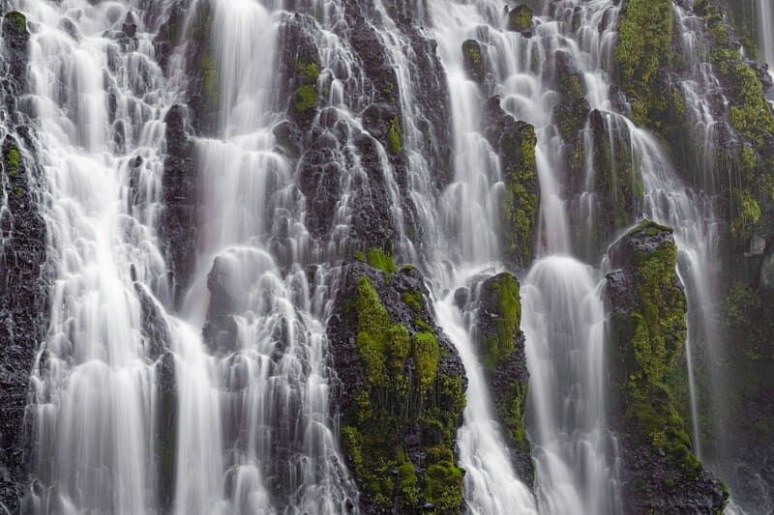Courtesy CA State Parks
The park's centerpiece is the 129-foot Burney Falls, which is not the highest or largest waterfall in the state, but possibly the most beautiful. Additional water comes from springs, joining to create a mist-filled basin. Burney Creek originates from the park's underground springs and flows to Lake Britton, getting larger along the way to the majestic falls.
The park's landscape was created by volcanic activity as well as erosion from weather and streams. This volcanic region is surrounded by mountain peaks and is covered by black volcanic rock, or basalt. Created over a million years ago, the layered, porous basalt retains rainwater and snow melt, which forms a large underground reservoir. Within the park, the water emerges as springs at and above Burney Falls, where it flows at 100 million gallons each day. Burney Falls was named after pioneer settler Samuel Burney who lived in the area in the 1850s. The McArthurs were pioneer settlers who arrived in the late 1800s. Descendants were responsible for saving the waterfall and nearby land from development. They bought the property and gave it to the state as a gift in the 1920s. This year, we experienced heavy snow in mid-February so the falls were flowing exeptionally heavy.
Cellular service in the park continues to improve, so you should be able to find a signal as you travel the roads.

Visitor Information for the Falls:
McArthur Burney Falls Memorial State Park entrance kiosk is open now, but closed in the off-season. Please bring exact change or credit/debit cards to pay by APM (Automatic Payment Machine) which is located just pass the entrance kiosk in front of the visitor center.
- Park Day-Use Fee - $10 Per Vehicle
- Overnight Camping - $35 Per Night (Includes One Vehicle).
- Additional Overnight Camping Vehicles - $10 Per night.

Warnings for Falls Vistors:
McArthur Burney Falls State Park experiences extremely high visitation beginning in April and continuing through October. Most weekends all summer the park will fill to capacity and entrance into the park is subject to closure due to limited parking availability. Visitors should expect traffic delays on State Highway 89 for up to an hour prior to entering the park due to the increased visitation experienced at this park. It is illegal to park along Highway 89 outside of the park for a mile either direction. If you park along Highway 89 your vehicle will be subject to citation and tow. The speed limit is 55 mph along Highway 89 and utilized by a large volume of semitrucks, it is not recommended to walk along the highway. If you arrive to find the entrance closed due to full capacity, please return at a later time - typically after 4:00 p.m.
The park cannot admit entrance to vehicles over 32 feet for day-use or camping. Additionally, only a limited number of oversized vehicles (less than 32 feet in length) will be admitted into park. Oversized vehicles will only be allowed to park in the Lake Britton parking lot (approximately 1.5 miles walk to the falls) on Fridays, Saturdays, and Sundays.
Due to limited parking capacity, McArthur-Burney Falls Memorial State Park cannot accommodate entry, drop-offs or parking of tour busses until further notice.

Castle Crags State Park
Majestic Castle Crags have inspired enduring myths and legends. More than 170 million years old, these 6000-feet tall granite spires in the Castle Crags Wilderness border the northwestern edge of Castle Crags State Park.

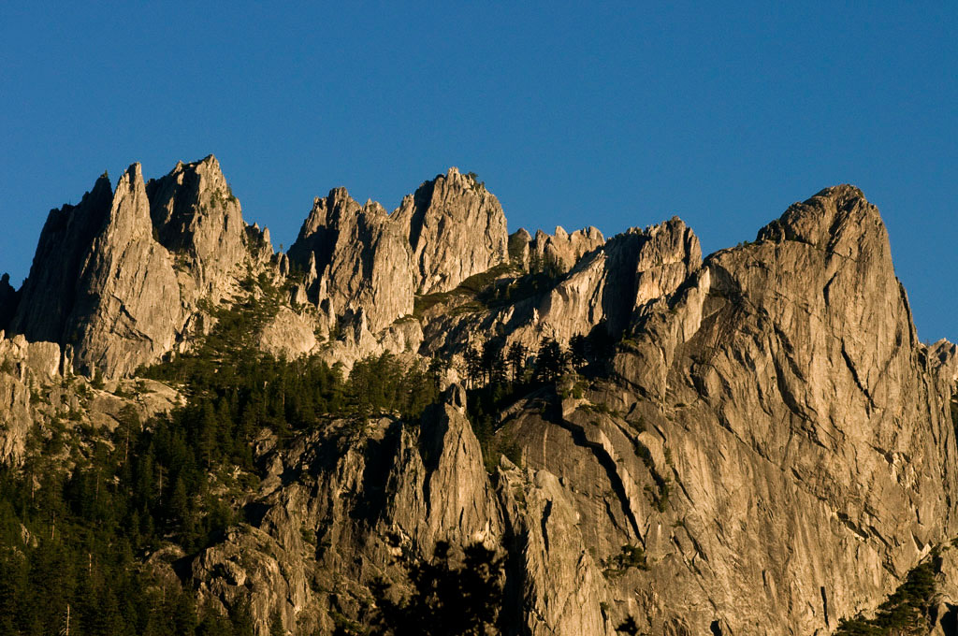Courtesy of California State Parks, 2026.
Castle Crags State Park offers a variety of camping, picnicking, hiking, and fishing opportunities.
The park has 76 developed campsites that are each equipped with a picnic table, food locker, and a fire ring. Flush toilets, showers, and drinking water are available near each campsite. Picnic sites are located along the Sacramento River and at the awe-inspiring Vista Point.McArthur Burney Falls State Park experiences extremely high visitation beginning in April and continuing through October. Most weekends all summer the park will fill to capacity and entrance into the park is subject to closure due to limited parking availability. Visitors should expect traffic With 28 miles of hiking trails, everyone can enjoy a mild stroll or an invigorating adventure. From the Vista Point parking area, a quarter mile accessible trail leads visitors to Vista Point where there are dramatic views of Castle Crags, Mount Shasta, and nearby Grays Rocks. Gentle and shaded, the mile long Root Creek Trail guides hikers along an accessible path to a year round flowing creek.
The most popular and challenging route is the Crags Trail which leads adventures to the base of Castle Dome where the views are simply breathtaking. The Pacific Crest Trail winds through the Park as well. Castle Crags State Park is often a respite for the weary hikers of this 2,650 mile trek from Mexico to Canada.
The Sacramento River flows through the park and has several access points that allow for fishing and hiking. Facilities at Riverside include camping and picnicking sites as well the famed pedestrian suspension bridge that crosses the Sacramento River.

Ahjumawi Lava Springs State Park
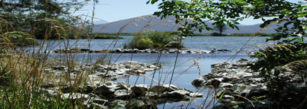
"Where the waters come together...." is a translation of the California Indian word Ahjumawi, which is also the self describing word used by the band of Pit River of Indians who still inhabit the area.
Ahjumawi is a place of exceptional, even primeval, beauty. Brilliant aqua bays and tree studded islets only a few yards long dot the shoreline of Ja-She Creek, Crystal Springs, and Horr Pond. Over two thirds of the area is covered by recent (three to five thousand years) lava flows including vast areas of jagged black basalt.
The park's backcountry is charactarized as wilderness with extremely rugged lava rock. Visitors should prepare adequately for their visit. While there are over twenty miles of park trails by which to explore this beautiful geographical wonder, please be advised that travel off the trails requires proper preparation and equipment. Be sure someone knows where you are going and when you expect to return.

Meet

The Newsletter Editor Tony Otto
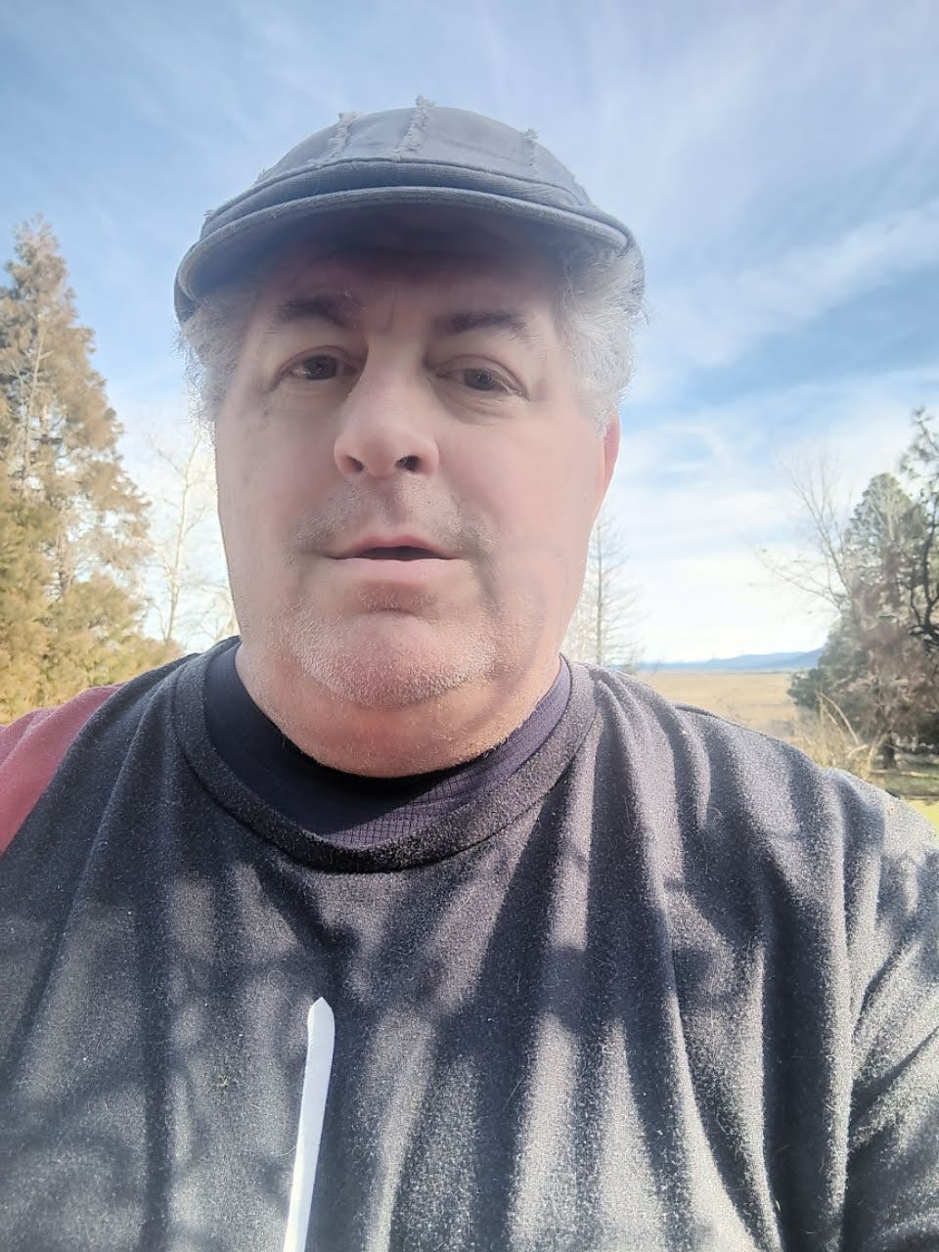
I visited the falls and nearby Lassen park during summer vacation a couple of times as a primary grade schooler and as a junior high student. Those were great memories, along with coming around a curve on CA-299 and coming upon a VW Beetle sized boulder that had fallen on the upward lane of the highway. I’m not sure my Dad was as amused as I was. Fifty plus years later, the opportuntity to live in Fall River Mills came about. Now I live a few short miles from the falls. I was asked to join the Board of Directors of the MBFIA and I greatfully accepted. When the need to resume the quarterly newsletter arose, I willingly took on the challenge.

Falls Visitor Center
The MBFIA operates the visitors center at the main parking lot above the falls. There you will find informative panels about the , the park, and the local flora & fauna. Several art exhibits are displayed in the center, including: Ed. Note: See this quarter’s featured artist below.

Visitor Center Store
The 2026 T-Shirts are now available at the Visitor Center Store.
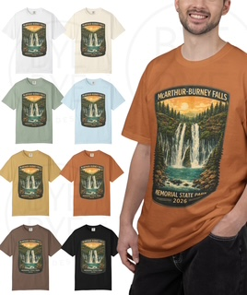
At the center, you will find these items for sale:
- Water Bottles and Mugs
- Stuffed Birds that frequent the park
- Patches and Badges
- Magnets and Pins
- Camping supplies
- Walking Sticks
- T Shirts with color print of McArthur Burney Falls
- Hats
- Sweatshirts
- Guides to Wildlife
- Gifts from Local Artists
  - Pottery
  - Pine Cone jewelry and tools
  - Watercolor originals and prints of the park

Featured Artist this Quarter:
Marla Nolan
I am a disabled artist living in Northern California with my wonderful husband Tim and black shelter cat Meowtian. I retired from my beloved career as Pharmacist in 2015 due to worsening chronic illness.
I have been creative my whole life. When I was still working, before my hands lost fine function and developed deformities from arthritis, I was often working on needle work, usually of a famous painting. Here is the last piece I completed:
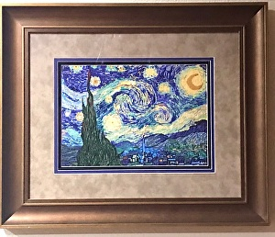
After I left work, an artist friend gave me a Sumi-E book thinking this might be something I could do. Enjoying it but wanting color, I found an online watercolor work at your own pace course in 2019. I fell in love with the beautiful transparency and glow of the medium. I became excited that you could express with paint not just beauty but the feelings you have about a place, person, or thing just by manipulating colors, light, and values. Painting for me is a distraction from pain and disability, and a time of meditation that brings me great joy!
With my website, my works, and my social media presence, I want to highlight how art can be beneficial as a therapy in chronic disease management (based on my experience). I hope my paintings will bring you the same happiness I felt during their creation each time they are viewed. Looking forward is easier now with a purpose, continual learning, community, and painting.
Ed. Note: See links to Marla’s website in the ‘On the Internet’ section at the bottom.

Burney Falls General Store
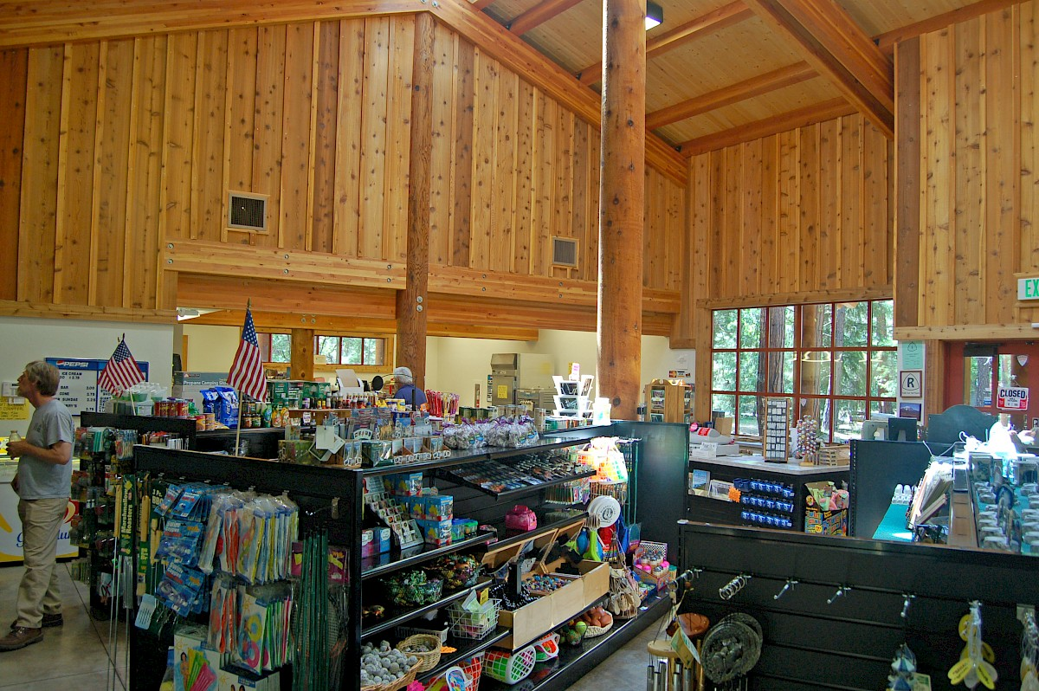
Conveniently located within Burney Falls State Park, the Burney Falls General Store is your go-to stop for essential supplies and quick refreshments. You’ll find a variety of cold drinks, tasty treats, and basic camping necessities—all surrounded by the beauty of the park’s towering pines and tranquil atmosphere. Friendly staff and a rustic setting make it a welcoming stop for campers and day visitors alike.
Ed. Note: See the link to the General Store website in the ‘On the Internet’ section at the end of this newsletter.

Job Openings

MBFIA Bookkeeper
The Association needs a bookkeeper/treasurer to join the Board on a volunteer basis. This is a great way to give back to the community, working with a group of like-minded people who get a kick out of helping to improve three local State parks, including MacArthur-Burney Falls Memorial State Park. Great for a retired person who wants to keep active up to 10 hours a week. Knowledge of Quick Books helpful. Contact Board President Jim Sacson at (530) 513-7102.

Camp Hosts

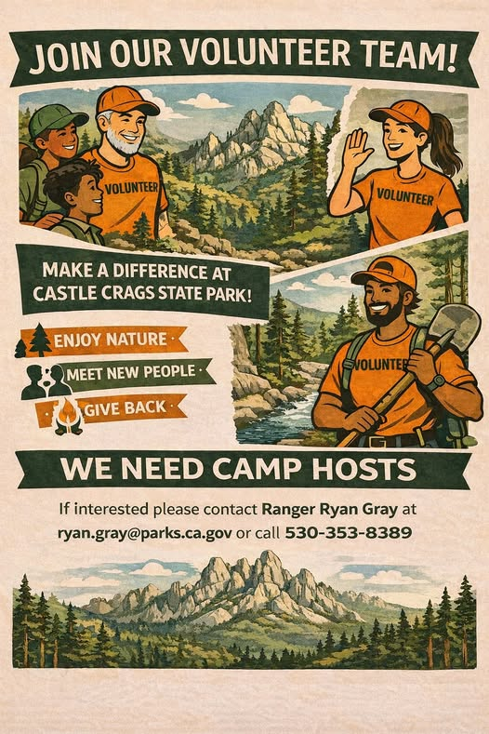
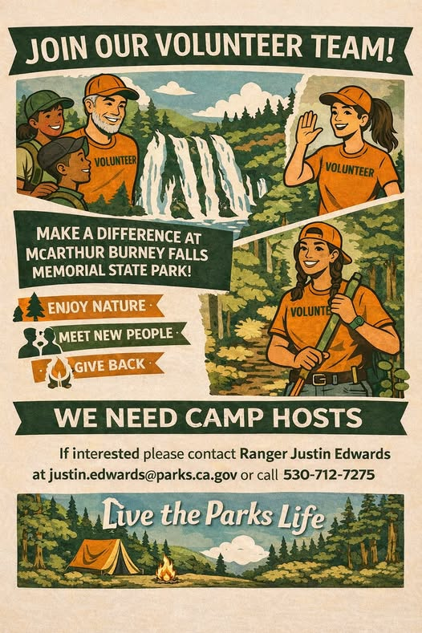
Visitor Services Senior Park Aide
The Visitor Services Senior Park Aide (Seasonal) is expected to work weekends, holidays, and evenings if necessary and assigned days off may vary from month to month. The Visitor Services Senior Park Aide (Seasonal) will perform duties dressed in full State Park uniform.
Primary duties include but are not limited to: Park Aide Lead and administrative duties such as maintaining accountability worksheets, attendance records, and Park Aide schedule, training new Park Aide staff, providing direction and assistance to Park Aide staff, and receptionist duties for the office. The Senior Park Aide (Seasonal) will also
operate the entrance station, greet visitors, and provide information about park conditions, closures, trails, and rules and regulations. In addition, the Senior Park Aide (Seasonal) should be proficient in basic use of a computer and able to check work e-mail account.

Memorial Tables
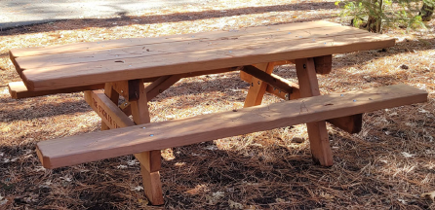
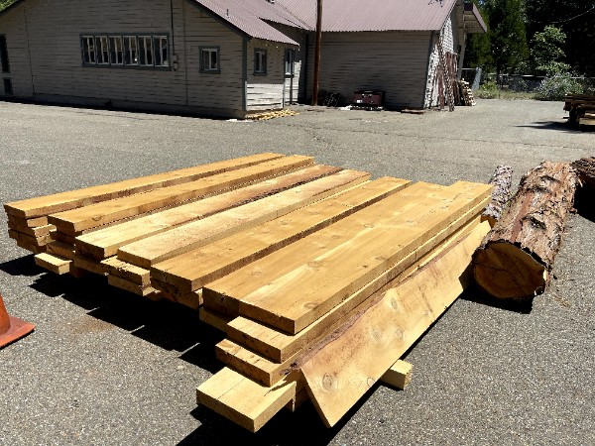
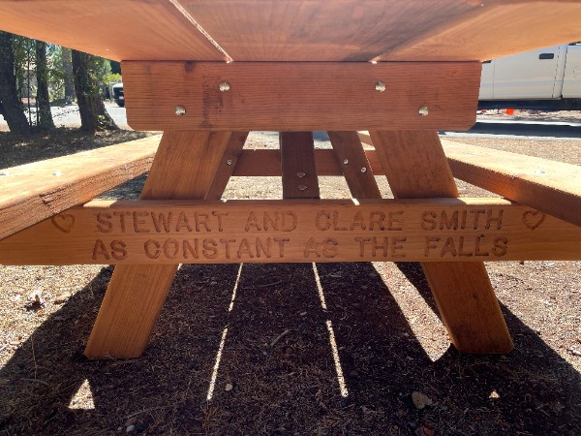
We are thrilled to offer you a limited opportunity to purchase an engraved memorial table to be placed in the Park for years to come! Here's your opportunity to contribute a tax-deductible gift to the Park and to create an everlasting memory of a special time at the park or in honor of a family member or friend, while contributing to the Friends of the Falls at the same time! Contact Bill McSweeney at: calpacker@comcast.net or 415-726-3241 for information and an application!The MBFIA builds memorial tables and places them throughout the parks. They can be purchased for $2800. Each end can have memorial information etched into the bench.

Tribute

A Tribute to Generations of Families Who Vacation At Burney Falls
For over forty years and probably more, families have gathered at McArthur Burney Falls Memorial State Park to spend time together. Grandparents, Uncles & Aunts, Cousins, Moms, Pops, and children camping, swimming, fishing, hiking, cooking, sleeping under the stars, roasting marshmallows, singing, and making strong memories. You may find their names on tables and benches throughout the park in memory of loved ones.
We would like to acknowledge the families that call this park home and have supported its interpretive services for at least the last ten years. The ones we know about are listed below. If you are not on the list, please let us know who you are and how long your family has been trekking to Northern California to spend time at our beautiful park.

Tribute to Families that call McArthur Burney Falls Home
- The Ashby Family – Susan, Bill, Bryan, Leslie & Brayden - 46 years
- The Busalacchi Family – 51years
- The Calkin Family – In Memory of Sandy Stefenoni
- The Case Family & the Kelly’s Wishes Foundation - In Honor of Kelly Case Moulton
- The Coughlin Family – In memory of Rober Vajretti and his Burney Legacy - 45 Years
- The Damato Family – 52 years
- The Doo Family – In honor of Jack & Cathy Doo
- The Garcia Family – In Memory of Dale Berliner - 30 years
- The Germeraad Family – In Honor of Stewart & Clare Smith – 4 generations
- The Gomez Family – In Memory of Sandy Stefenoni - 46 years
- The Gutilla Family- In Honor of Daniel Ries. Our families have been visiting Burney Falls for decades.
- The Hesselroth & Russell families - In memory of Mrs. Pamela Russell and her husband, John, who began vacationing at McArthur Falls in the 1970’s. – 50 Years
- Kamp Kearney – - A family tradition for more than 46 years and keeping the tradition going for 100 more in honor of Tim and Joy Kearney.
- The McKay Family – 52 years
- The Miller Family - 46 years
- Tom & Mary Pilla- Honoring John Roderick McArthur, nephew of Frank McArthur of the McArthur Family, who bequeathed the park to the citizens of California.
- The Stefenoni Family – 46 Years
- The Strickler Family
- The Taube Family
- The Towle Family – In Memory of Tom Garcia – 116 years
- The Van Aken Family – 62 years
- The Vitale Family – In Memory of Scott Lunger – 29 years
- The Wilbur Family – In Memory of Linda Wilbur - 51 years
- The Zwanziger Family – In honor of grandchildren Callen, Kassidy, Kamille and Chase- 60 years
Thank you all for your love and support of this beautiful park.

Contact Infomation
- MBFIA (McArthur-Burney Falls Interactive Association), PO Box 777, Burney 96013, friends@burneyfallspark.org
  - Board President Jim Sacson: jimsacson@gmail.com, (530) 513-7102
  - Webmaster Bob Boyce: webmaster@burneyfallspark.org
  - Tablemaster Bill McSweeney: calpacker@comcast.net
  - Newsletter Editor Tony Otto: tony.otto.frm@gmail.com, (530) 610-2133
- McArthur-Burney Falls Memorial State Park, 24898 CA Hwy 89, Burney, CA 96013,(530) 335-2777
  - Falls Ranger Justin Edwards, justin.edwards@parks.ca.gov, (530) 712-7275
- Burney Falls Visitor’s Center: (530)‌ 335-3171
- Castle Crags State Park, 20022 Castle Creek Road, Castella, CA 96017, https://castlecragspark.org/
  - Crags Ranger: Ryan Gray, ryan.gray@parks.ca.gov, (530) 353-8389

On the Internet

MBFIA (McArthur-Burney Falls Interpretive Association)
https://burneyfallspark.org/
https://www.parks.ca.gov/?page_id=28535
https://www.facebook.com/BurneyFallsPark/
https://burneyfallspark
.networkforgood.com/
https://projects.propublica.org/nonprofits/organizations/680041373

Burney Falls General Store
https://burneyfallshospitality.com/

MacArthur-Burney Memorial State Park
https://www.parks.ca.gov/?
page_id=455

https://en.wikipedia.org/wiki/McArthur
%E2%80%93Burney_Falls_Memorial
_State_Park
https://www.facebook.com/mbfmsp/
https://www.tripadvisor.com/
ShowUserReviews-g32125-d102684-
r240734010-
McArthur_Burney_Falls_Memorial_St
ate_Park-Burney_California.html
https://www.reddit.com/r/
norcalhiking/comments/1l2y6v9/
mcarthur_burney_falls/

Castle Crags State Park
https://www.parks.ca.gov/?
page_id=454
https://castlecragspark.org/
https://en.wikipedia.org/wiki/
Castle_Crags
https://wilderness.net/visit-
wilderness/?ID=103

Ahjumawi Lava Springs State Park
https://www.parks.ca.gov/?
page_id=464
https://www.visitcalifornia.com/
experience/ahjumawi-lava-springs-
state-park/
https://www.shastacascade.com/
account/ahjumawi-lava-springs-state-
park
https://en.wikipedia.org/wiki/
Ahjumawi_Lava_Springs_State_Park

April Featured Artist: Marla Nolan
https://www.rheum2cre8art.com/
https://linktr.ee/rheum2cre8art

Secret San Francisco Article
https://secretsanfrancisco.com/burney-falls-california-eighth-wonder-of-the-world/

